JAVA TEST 3

1. CREATE AN ARRAY LIST AND ADDING THE ELEMENTS TO THE LIST [LION, TIGER, CAT, DOG] BY ADDING AN ELEMENT AT PARTICULAR INNDEX AND USE FOR EACH LOOP TO DISPLAY ALL THE ELEMENTS IN THE ARRAY

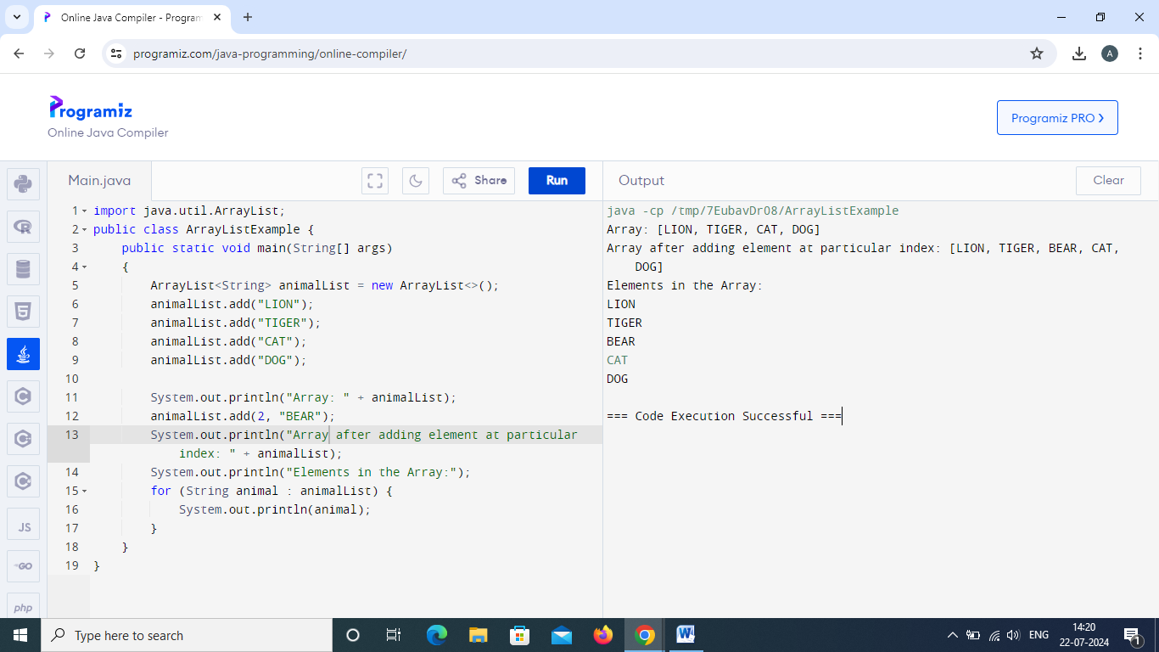

1. CREATE ARRAY LIST TO INSERT NUMBERS 2,4,5,6,8,9AND DEMONSTRATE SIZE OF ARRAY LIST DEMONSTRATE GET AND SET METHOD.

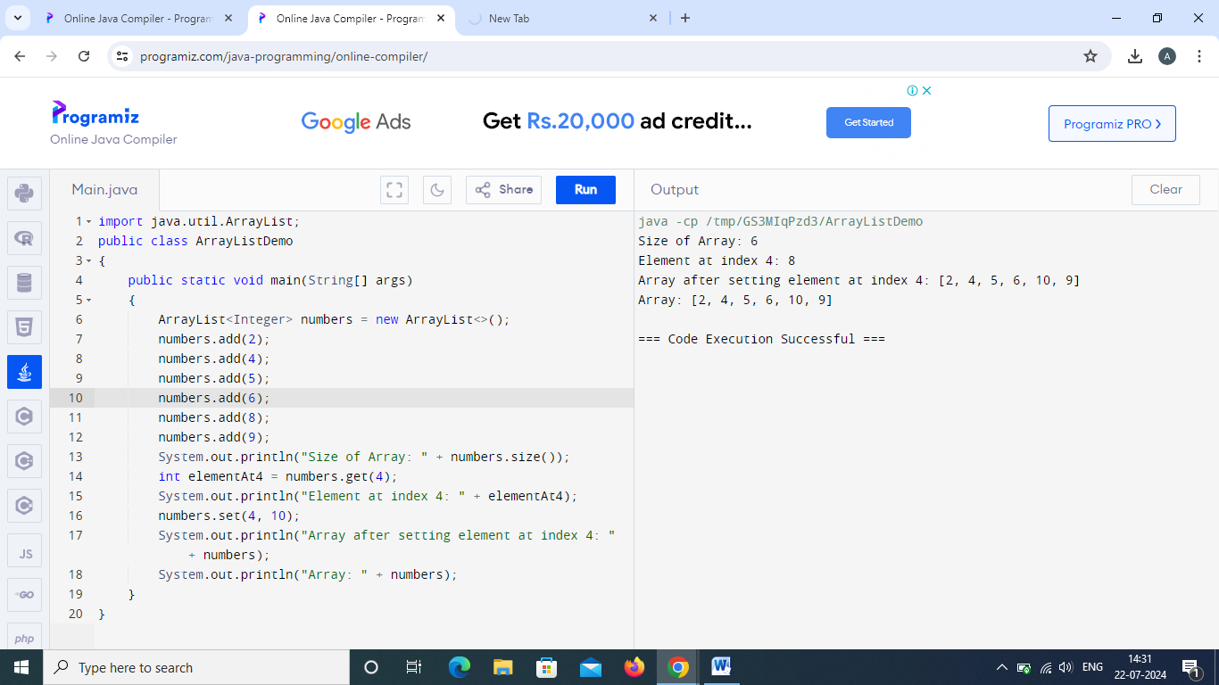

3. CREATE THE ARRAY LIST WITH ELEMENTS C ,C++ ,JAVA ,PYTHON, RUBY , JAVASCRIPT DEMONSTRATE THE FOLLOWING

A.REMOVE ELEMENT FROM A PARTICULAR INDEX

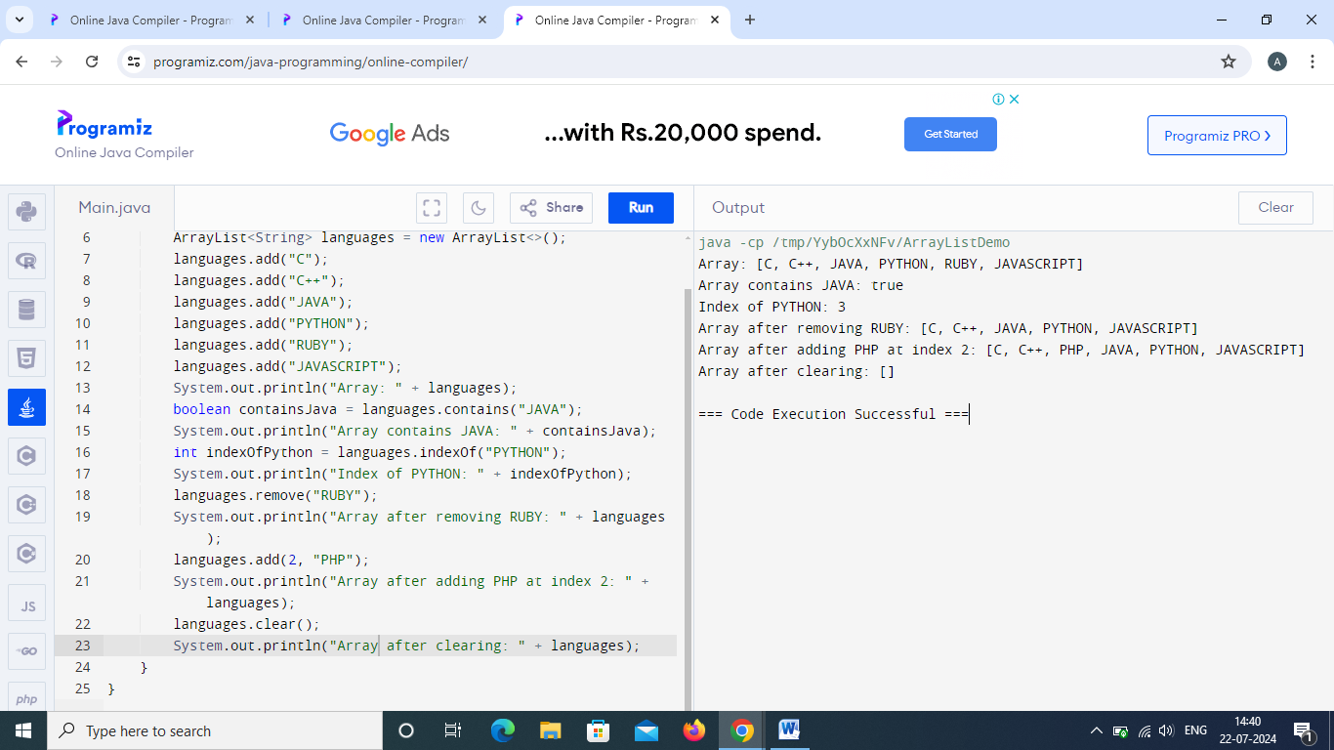

1. CREATE ARRAY LIST RAJA,RAVI,RAMU,VIMAL,ROJA DEMONSTRATE ITERATE OVER AN ARRAY LIST USING FOR EACH ITERTOR ,LIST ITERATOR.

